|  |  |
| --- | --- |
| Math.sin (double a) | Returns the trigonometric sine of an angle. Note, angles must be entered in Radians not Degrees. To convert from Degrees to Radians you multiply by . Eg. 30o = |
| Math.cos (double a) | Returns the trigonometric cosine of an angle |
| Math.min (double a, double b) | Returns the least of two double values (will also work with long, float and int data types) |
| Math.max (double a, double b) | Returns the greater of two double values (will also work with long, float and int data types) |
| Math.sqrt (double a) | Returns the square root of a double value |
| Math.pow (double a, double b)) | Returns the value of the first argument raised to the power of the second argument |
| Math.random () | Returns a real number (double value) with a positive sign, greater than or equal to 0.0 and less than 1.0 |

**Math.random**

Math.random() method returns a random number between 0 and 1. You can increase the range of numbers by multiplying the random number result by the range of numbers you want. The (int) placed before the Math.random method will return a rounded down integer result.

* Using (int)(Math.random() * 5): Will give you 5 random numbers from 0,1,2,3,4 *Note: 0 is a number*
* Using (int)(Math.random() * 10): Will give you 5 random numbers from 0,1,2,3,4,5,6,7,8,9 *Note: 0 is a number*

You can shift the series of random numbers by adding or subtracting to the random number result

* Using (int)(Math.random() * 5) + 4: Will give you 5 random numbers from 4,5,6,7,8
* Using (int)(Math.random() * 10) - 4: Will give you 5 random numbers from -4,-3,-2,-1,0,1,2,3,4,5

**Math.floor**

To round down, you can use the need to add the Math.floor() method. This method returns the largest integer that is less than or equal to the argument, but it return it as a double.

For example

double w = 100.675;

double x = -100.675;

double y = 90.0;

double z = -90.0;

System.out.println(Math.floor(w)); -> returns 100.0

System.out.println(Math.floor(x)); -> returns -101.0

System.out.println(Math.floor(y)); -> returns -90.0

System.out.println(Math.floor(z)); -> returns -90.0

**Math.ceil**

To round up, you can use the need to add the Math.ceil() method. This method returns the smallest integer that is greater than or equal to the argument, but it return it as a double.

For example

double a = 100.675;

double b = -100.675;

double c = 90.0;

double d = -90.0;

System.out.println(Math.ceil(a)); -> returns 101.0

System.out.println(Math.ceil(b)); -> returns -100.0

System.out.println(Math.ceil(c)); -> returns -90.0

System.out.println(Math.ceil(d)); -> returns -90.0

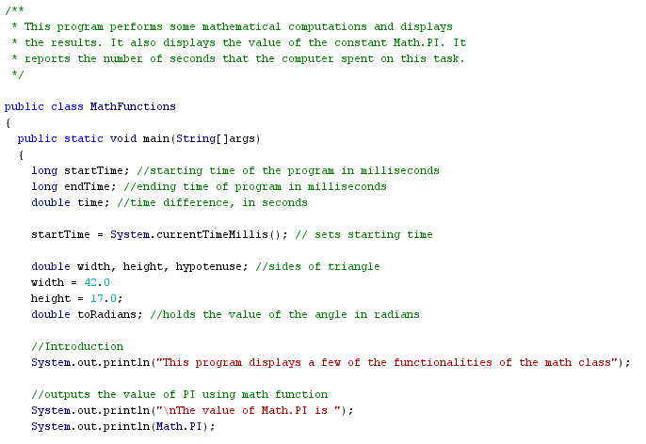

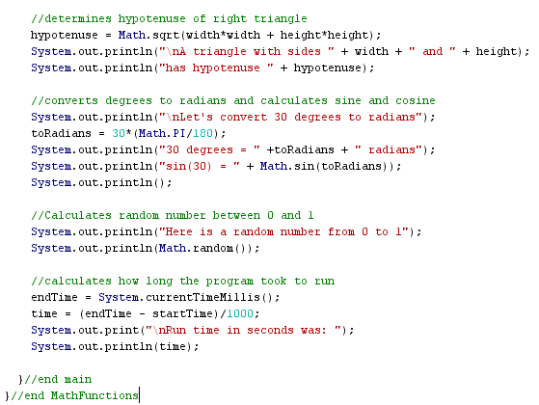

**Task #1:**

1. **Type in the code for the above program, compile and check for errors.**
2. **Change the code so that the user can input the base and height of the triangle.**
3. **Change the code so that the user can input the angle in degrees.**
4. **Change the code so that it calculates an integer between 1 and 100.**
5. **Extra: Change the input and output to be done through JOptionPane’s.**

**\*\* Good video on the use of JOptionPane  
  
https://www.youtube.com/watch?v=E3JQrxxQKIo&t=1s**